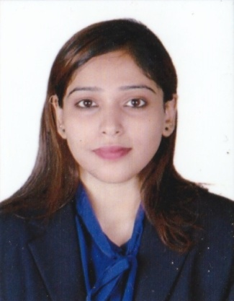
CURRICULUM VITAE

Name: Swapnali Naik Desai
Email: swapnalindesai@gmail.com
Contact No: +91 855 388 2656

Career objective: To pursue a career in Marketing, in a highly professional unit and utilize my organizational and customer service skills, in order to increase the productivity of the organization.

Areas of Competence: Core marketing activities, sales, media and advertisement, market research, public relations, brand Management and digital marketing.

Education Details:
Qualification | College/ University | Year of Passing | Percentage (%)
M B A (Core Marketing ) | CMS Business School-Jain University | 2015 | 86%
M.Sc. Biotechnology | Indian Academy Institute  Bangalore University | 2012 | 78.2%
B.Sc. Biotechnology | Dhempe College of Arts & Science  Goa University | 2010 | 81.2%
12th PUC-PCB | Shree Damodar HSSCE of Science  Goa Board | 2007 | 81.8%
10th | Maria Bambina Convent High School, Goa Board | 2005 | 84.6%

Internship details: Interned at TV House Network Pvt Ltd, Bangalore for 2 months from June-August 2014. The Internship was focused on the area of Event Management and Public Relations.

Research Project: "Creation of an Effective Event Management Model aimed towards maximizing the satisfaction levels of target consumers from the above mentioned Company".

Organization Study: Completed Organization study from Biocon India Ltd., doing cross functional study of the organization and studying the overall organizational working.
Work Experience: Nil
Job Responsibilities:
- Strong people and project management skills
- Able to realistically judge project time and deliver on schedule
- Adaptive, Versatile, Confident & Self motivated
- Excellent Communication skills
- Self starter and fast learner.
Projects and Certifications Undertaken :
- Pursuing Marketing Course (Level 4) from the Chartered Institute of Marketing.
- Won Best HR award at National level inter college Management fest "Shatranj" organized by SDM College, Mangalore in Feb 2015.
- Won Runner up award in HR at National level inter college Management fest "Naissance" organized by SDMIMD, Mysore in Jan 2015.
- Won Best HR award at inter college fest "Arthayudh" organized by Christ University, Koramangala in Dec 2014
- Won best HR award at Inter college fest "Archish" organized by IBA Institute in March 2014.
- Entrepreneurial skills development training from Micro, Small & Medium Enterprises-Development Institute (MSME), Bangalore.
- Advanced training in Chromatographic methods of separation, Spectrophotometric methods of analysis and Water analysis from Advanced Training Institute, Chennai.
- Industrial summer training in Production, packaging and quality control and analysis from United Breweries Ltd (UBL) and United Spirits Ltd (USL), Goa.
- Certificate course in C Programming from Dhempe College of Arts and Science, Goa.

Extra Curricular Activities: Inter college Management fests in HR and Marketing, Reading, Singing, listening to music, playing badminton/volleyball, watching movies, adventure sports.

Personnel Details:
Date of Birth : 9th December 1989
Father’s name : Ramnath Naik Desai
Languages known: English, Hindi, Konkani and Marathi

Declaration:
I, hereby declare that the above information is true and to the best of my knowledge.
Date: - / /2015 Place: Bangalore

